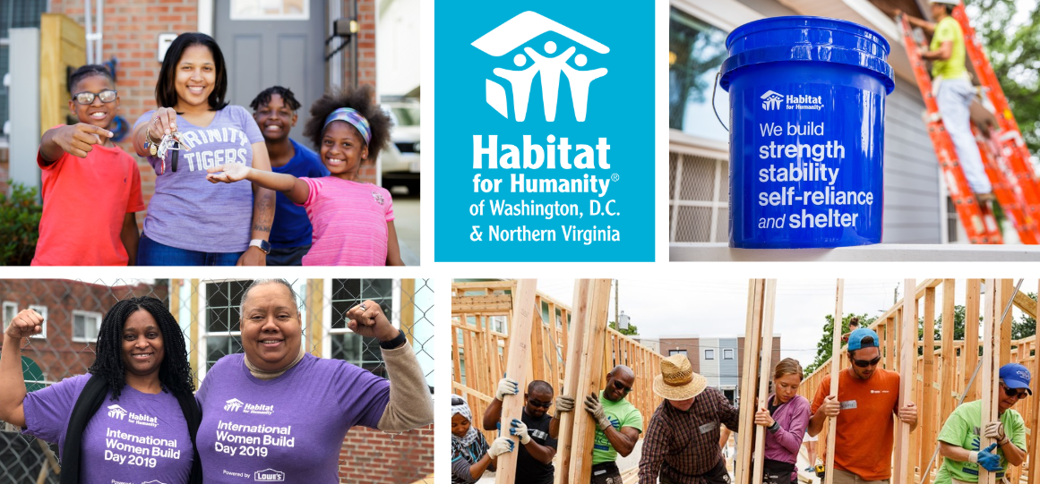
Volunteer
Manual
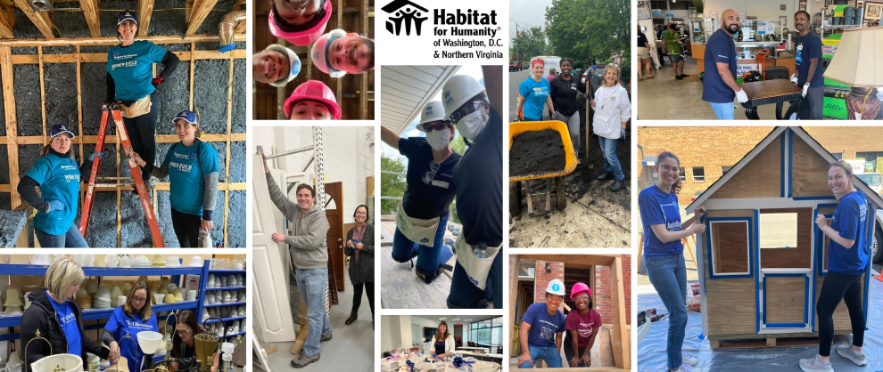

Last updated: 01/13/2026
TABLE OF CONTENTS

Welcome 2
About habitat DC-NOVA 3
Habitat DC-NOVA 3
Habitat for Humanity International 3
Staff 4
Office and ReStore Locations 5
FAQ’s 6
Volunteers at habitat DC-Nova 7
Becoming A Volunteer 7
Construction Volunteers 10
ReStore Volunteers 12
Office Volunteers 16
Court-Ordered/Pre-Trial Volunteers 17
Volunteer Policies 18
Minimum Age of Volunteers 18
Volunteer Rights and responsibilities 18
Harassment and Discrimination 19
Site Safety 20
Confidentiality 21
Background Checks / Screening 21
Weapons 21
Drug and Alcohol 21
Termination 22
Volunteer Appreciation 22
Volunteer Feedback 23
Appendices 24
Volunteer Waiver 24
Medical Incident Report Form 27
Harassment Complaint Form 30
Background Check and Sex Offender Registry Check 31
Confidentiality Agreement 38
Volunteer Dismissal Form 39

Welcome!
Habitat for Humanity of Washington D.C. & Northern Virginia (Habitat DC-NOVA) builds and preserves affordable homeownership opportunities in our communities. You are a key part of making our work possible, so thank you for volunteering!
We understand that there are many great causes to volunteer with, and we value your commitment and time. As part of that, we want to make sure you have access to our volunteer policies, your rights and responsibilities as a volunteer, and other information to make your volunteer experience a success. This volunteer manual will include that information to get you ready to volunteer and support you as you volunteer. If you have any questions or suggestions, we welcome your input and encourage your communication.
Thank you again for sharing your time and talents with Habitat for Humanity of Washington D.C. & Northern Virginia.
Sincerely,
Rachel Jones
Director of Volunteer & Community Engagement

Habitat DC-NOVA
Habitat DC-NOVA rallies our community together to help families build strength, stability, and shelter. Through affordable homeownership, we can empower families for generations to come.
We serve families whose income is 30-80% of the area median income (AMI), and may have a challenging time purchasing a home on the open market. We build across Washington, DC, Arlington County, Fairfax County, and the Cities of Alexandria, Falls Church, and Fairfax.
Since our founding, we have built or rehabilitated homes for more than 400 families and improved the lives of hundreds of people living in our local communities.

Habitat for Humanity International

Habitat for Humanity International (HFHI) is a nonprofit, ecumenical Christian housing ministry. HFHI’s vision is a world where everyone has a decent place to live and its mission is to put God’s love into action by bringing people together to build homes, communities and hope. HFHI seeks to eliminate poverty housing and to make decent shelter a matter of conscience and action. Through volunteer labor and donations of money and materials, Habitat builds and rehabilitates simple, decent houses with the help of partner families.

Founded in 1976 by Millard and Linda Fuller, HFHI has served more than 13 million people worldwide, providing them with safe, decent, affordable shelter. HFHI has headquarters in Americus and Atlanta, Georgia. The organization now has more than 1,100 local affiliates in the United States and operates in more than 70 countries globally.

Staff
Leadership Team
Susanne Slater, Executive Director (Susanne.slater@habitatdcnova.org)
Andrew Modley, Vice President of Construction (Andrew.modley@habitatdcnova.org)
Kat Shaub, Vice President of Development (kat.shaub@habitatdcnova.org)
Scott Martin, Assistant Vice-President of the ReStores (scott.martin@habitatdcnova.org)
Construction Staff
Kelly Renaud, Director of NOVA Construction (Kelly.renaud@habitatdcnova.org)
Dan Hines, Director of D.C. Construction (dan.hines@habitatdcnova.org)
Drew Tse, NOVA Construction Superintendent (drew.tse@habitatdcnova.org)
Dennis Monaghan, D.C. Construction Superintendent (dennis.monaghan@habitatdcnova.org)
John Hare, D.C. Construction Superintendent (john.hare@habitatdcnova.org)
ReStore Management
Dustin Miller, Alexandria ReStore Manager (dustin.miller@habitatdcnova.org)
James Snowden, Chantilly ReStore Manager (james.snowden@habitatdcnova.org)
Paul Scherer, Herndon ReStore Manager (paul.scherer@habitatdcnova.org)
Volunteer Services Staff
Rachel Jones, Director of Volunteer & Community Engagement (rachel.jones@habitatdcnova.org)
Mahnoor Zafar, Volunteer & Community Engagement Manager (mahnoor.zafar@habitatdcnova.org)
Timara Broadnax, Volunteer Services Coordinator (timara.broadnax@habitatdcnova.org)
Giulia DeLuca, ReStore Volunteer Coordinator, (giulia.deluca@habitatdcnova.org)

Habitat DC-NOVA Locations

Main office
4245 North Fairfax Dr. #650
Arlington, VA 22203
(703) 521-9890

Alexandria ReStore
869 South Pickett Street
Alexandria, VA 22304
(703) 360-6700
Chantilly ReStore
4311 Walney Road
Chantilly, VA 20151
(703) 953-3747
Herndon ReStore
311 Spring St.
Herndon, VA 20170
(571) 306-0908
Shopping Hours:
Tuesday– Friday: 10 a.m. – 6 p.m.
Saturday: 9 a.m. – 5 p.m.
Visit us online at: habitatdcnova.org
Facebook: https://www.facebook.com/HabitatDCNOVA
LinkedIn: https://www.linkedin.com/company/habitatdcnova
Instagram: https://www.instagram.com/habitatdcnova/
Frequently Asked Questions
How do people get a home?
Habitat for Humanity D.C. – NOVA provides a unique opportunity for families with low and moderate incomes to buy their own homes. Our houses are sold below market value to families who qualify for a monthly housing payment that is no more than 30% of their monthly income. We work alongside the families we serve to provide them with the knowledge and tools they need to become successful homeowners, and we offer support and guidance through every step of the homebuying process. To become a homeowner, applicants must demonstrate housing need, meet income and credit requirements, have a manageable level of debt, and spend time building their home alongside our construction team and volunteers.To learn more, visit our website at https://www.habitatdcnova.org/what-we-do/homeownership/.
How do you fund your projects?
Habitat DC-NOVA relies on several sources to fund our mission. Corporations, foundations, and individuals provide generous support through direct financial donations and by offering their time to volunteer with us. Then, our ReStores are nonprofit home improvement stores and donation centers that sell new and gently used furniture, appliances, home accessories, building materials, and more. All our items are donated by businesses, building contractors, suppliers, and individuals, and are available for sale to the public at 50% to 90% off the original retail prices. Habitat DC-NOVA also sponsors events throughout the year to raise additional support. Finally, we participate in the Cars for Homes program, which allows community members to donate the proceeds from the sale of their used cars to Habitat DC-NOVA.
How do the ReStores fit into your mission?

Habitat DC-NOVA ReStores help build strong and stable families and communities by:
- Generating proceeds that directly support Habitat DC-NOVA’s programs and services
- Offering an affordably priced and diverse selection of home improvement materials
- Serving as community repurposing centers, diverting millions of pounds items from D.C and NOVA landfills
Providing a worthwhile community service with numerous volunteer opportunities

Becoming a Habitat DC-NOVA Volunteer
Whether picking up a hammer on one of our construction sites, helping a customer pick out an item at our ReStores, or assembling welcome baskets for families, volunteers make the work we do possible. If you think you can help in another way, please reach out to us and we’ll be happy to discuss it!
Interested in volunteering as a group?
Please complete our interest form at https://www.habitatdcnova.org/get-involved/volunteer/volunteer-group-interest-form/ or email volunteer@habitatdcnova.org.
We ask all groups to first connect with a volunteer services staff member to officially schedule your volunteer event.
Signing up to volunteer as an individual
Volunteers are asked to sign up online for all of our opportunities at https://vhub.at/HabitatDCNOVA. For individuals interested in ReStore opportunities, please sign up for an orientation time that works best for you. Upon completing our ReStore orientation, you will be able to sign up for any ReStore opportunities. For individuals interested in a community build day, you can directly sign up for those events when they are posted and attend the orientation on-site the morning of the build day.
Need hours for court-related reasons?
We do accept volunteers who need verification letters for school, work, or court. However, we are unable to accept court-related volunteers with any violent offense, sexual misconduct, or grand larceny charge. Then, for any court-related reasons, whether it is pre-trial or not, we ask volunteers to complete a screening process. Please see below.
Step one: Create an account at https://vhub.at/covols.
Step two: A staff member will confirm that we can accept your charge and communicate next steps within 48 hours
Step three: Once approved, you are free to register for an upcoming volunteer shift.
If you have already volunteered and now you need hours for court or you need hours for an additional charge, please update your information by going to https://vhub.at/covols, clicking your name at the top right corner, and updating your profile.
Please go to the three lines at the top right-hand corner and click "manage affiliations" and select "I need court-related community service hours." Then go back to the three lines and click on "my profile." If you scroll to the bottom, you'll see more questions about your case. Please upload an official document that states your name and charge (such as a ticket from a police officer or court document). The document must state your charge so that we can complete a screening before your volunteer.
If you do not complete the screening process at the beginning of your service, you risk not receiving a verification letter, especially when it is a charge that we cannot accommodate.
For general individual volunteers, create your account
Step one: Go to https://vhub.at/HabitatDCNOVA
Step two: Create an account (or sign in if you already have an account)
Step three: Create a username and password for your account.
Step four: If you were sent a join code, you can enter it here. Most volunteers do not have join codes so you can probably skip this step!
Step five: If you are interested in a specific activity, please check the box(es) that match your interests. We use these to send out emails when we have specific needs for a project.
Step six: Complete your application. If your information ever changes, you can always log in to the system and update it.
Now, you have an account, and you can sign up for a community build day or ReStore orientation that works best for you. As a reminder, all ReStore volunteers must complete an orientation prior to volunteering. Once you have completed an orientation, you are able to sign up for any ReStore shift that works for you.
Some Helpful Tips
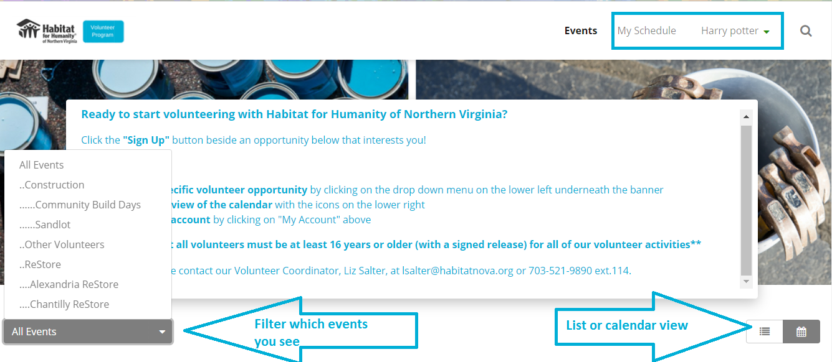
- You can filter your view of which events you see. If you want to volunteer at a specific ReStore, you can filter to see only those openings. You can also filter for other activities as well.
  - Community builds are open to any individual aged 16 years or older. Generally, we post those opportunities two weeks before the build so if you don’t see an opportunity, check back at a later time. If you are not seeing a specific opportunity and you have questions about it, you can always reach out, and we can provide more information.
- You can change your view of the page from a calendar view to a list view if that is easier for you to see and sign up for events.
- You can also see the schedule of events you’ve signed up for by clicking on the schedule button at the top of the page.
- You can update your account, change your password, and see the hours you’ve volunteered by clicking on your name at the top of the page.
Signing up for a Volunteer Activity
To sign up for a volunteer activity on VolunteerHub, you just need to click on the name of the activity. If all the slots are already filled for the opportunity, you may be able to join the waiting list. If you join a waiting list, you’ll receive a confirmation email if a slot becomes available.
If this is your first time volunteering, you’ll be asked to complete a waiver. This is required for all volunteers. Every year, you will automatically be prompted to sign the waiver again when you sign up for an activity.
Please note, if you are under 18, you will be emailed a waiver that a parent or guardian will need to sign. You can bring that waiver with you when you first volunteer, and it will be recorded in the system. Your parent and/or guardian can also complete that waiver online.
Construction Volunteers
Volunteers help with a variety of activities on both our sites. Volunteers are asked to commit to volunteering for the entire day, from 8:30 am to 3:30 pm, unless otherwise noted. All volunteers must be 16 years or older to volunteer. Volunteers under 18 cannot use power tools on site.
Before You Arrive
- All volunteers must sign up on VolunteerHub before volunteering.
- If want to bring friends or family members to volunteer with you, you must have each person sign up individually If you are 16 or 17 years old, you must have a parent or guardian sign a waiver and bring it with you.
- Follow the dress code
  - Comfortable, casual clothes (long, loose pants, long or short sleeve t-shirts) that you can work in and don’t mind getting dirty or paint on
- We do not recommend wearing shorts for your safety but if you are going to wear shorts, they need to be at least mid-thigh length and cannot be too tight. You may not be able to do all activities on site for your safety.
  - Closed-toe, closed-heel shoes such as athletic sneakers or work boots with a good tread and a hard sole.
  - Jacket, sweatshirt, and/or raincoat – often tasks require you to be outside, or near open doors or windows, so many volunteers find it helpful to layer their clothing

- Do NOT wear
  - Open-toed shoes, ballet shoes, high heels, crocs, cloth shoes, flip-flops, etc. (if you arrive wearing inappropriate footwear, you will not be permitted to work that day)
  - Loose hanging jewelry
  - Clothing that restricts your movement by being too loose or too tight
  - Anything featuring offensive or explicit slogans/language/images
- Pack a lunch, snacks, and beverages. We provide water for all volunteers onsite but if you want something more specific, please feel free to bring it with you.
- All sites have first aid kits, but if you need any personal medical supplies, please bring them with you. Note that we often do not have refrigeration on site.

When You First Arrive

- Arrive on time. All volunteers must attend an orientation and safety briefing. Even if you have volunteered before, you’ll be asked to attend as safety procedures may have changed. We do not start orientation until all volunteers have arrived.
- Park in the area described in your volunteer confirmation email.
- Check in with the volunteer coordinator or site manager to sign in and get your nametags.
  - If you do not have a waiver recorded in our system, you’ll be asked to sign one onsite.

Other helpful information to know

- We will pair you with one of our crew leader volunteers or AmeriCorps members. Our crew leader members are experienced volunteers who work at least twice a month, attend trainings, and lead other volunteers through their tasks.
- We provide all necessary Personal Protective Equipment (PPE) that you’ll need on site. This may include a hard hat, gloves, safety glasses, knee pads, ear plugs, or other items. Your crew leader will let you know which PPE items you’ll need.

  - Your safety is a primary concern. If you are not wearing the correct items, you’ll be asked to stop your activity and get them.

- We also have a first aid kit onsite and our staff are certified in First Aid and CPR.
- If you are uncomfortable with the task you are given or have questions, please let us know! We want you to have a great experience so don’t hesitate to ask questions or for more instruction.
- No illegal drugs or alcohol will be allowed on the worksite. Any volunteers found under the influence will be asked to leave immediately and will not be able to volunteer in the future.
- If you are unable to attend the event after registering, we ask that you cancel your registration on VolunteerHub as soon as possible. If it is within 48 hours of the build, please email volunteer@habitatdcnova.org that you will be unable to make it, so we can prepare accordingly. For those who do not go through this process, you will be marked as a no-show in our system, which may limit your ability to register for future build day opportunities if it becomes a habit.

Crew Leader or Sandlot Volunteers
Our crew leaders, or as our crew leaders in Northern Virginia call themselves, Sandlot, are critical to Habitat DC-NOVA being able to carry out its mission. If you are interested in volunteering on a regular basis AND are willing to lead other volunteers, please speak with our construction staff, and they’ll provide more information on the program, commitments, and how to get involved.

Our crew leaders volunteer at least 2-3 times a month. They help lead volunteer groups alongside our construction staff. We ask potential crew leaders to join us on-site a few times to see if it is a good fit. You can sign up for upcoming opportunities here (https://vhub.at/crew1leader).

ReStore Volunteers
Volunteers help with a variety of activities on our ReStores, such as assisting customers, receiving donations, organizing inventory, setting up displays, and keeping the store clean and organized. The activities change daily depending on the need. Volunteers are asked to commit to volunteering for at least two hours. All volunteers must be 16 years or older to volunteer.
Before You Arrive
- All individual ReStore volunteers must complete an orientation prior to volunteering at the ReStore, and these orientation times are on VolunteerHub.
- If you are interested in volunteering as a group, please complete our group volunteer form at https://www.habitatdcnova.org/get-involved/volunteer/volunteer-group-interest-form/ or email volunteer@habitatdcnova.org.
  - After your ReStore orientation, please sign up for a shift on VolunteerHub prior to volunteering. If want to bring friends or families to volunteer with you, you must have each person sign up individually
- If you are 16-17 years old, you must have a parent or guardian sign a waiver and bring it with you or have them sign it electronically online
- Follow the dress code
  - Comfortable, casual clothes that you can work in and don’t mind getting dirty or paint on (long, loose pants, long or short sleeve t-shirts)
  - Closed-toe, closed-heel shoes such as athletic sneakers or work boots with a good tread and a hard sole.
  - Jacket, sweatshirt, and/or raincoat – often tasks require you to be outside, or near open doors or windows, so many volunteers find it helpful to layer their clothing
  - Wear a volunteer apron and nametag provided at the register
- Do NOT wear
  - Open-toed shoes, ballet shoes, high heels, crocs, cloth shoes, flip-flops, etc. (if you arrive wearing inappropriate footwear, you will not be permitted to work that day)
  - Loose hanging jewelry
  - Clothing that restricts your movement by being too loose or too tight
  - Anything featuring offensive or explicit slogans/language/images .
- Pack a lunch, snacks, and beverages.
- All ReStores have first aid kits, but if you need any personal medical supplies, please bring them with you. .

When You First Arrive
- Sign into VolunteerHub. This allows us to keep track of volunteer hours and lets us know who is onsite.
  - Select “Existing User”
  - Type in your first name and click “Go”
  - Select your name
  - Click “Continue”
  - Select the correct ReStore location and shift
  - Click “Continue”
  - Note that you will sign out at the end of your shift and any time you leave the property (e.g. if you leave to grab lunch).
- Check in with the volunteer coordinator or Store Manager to get a nametag, apron, and assignment for the day.
  - You must wear your apron and nametag all day.
  - If you finish your assignment, please check in with a staff member to see what other task you can complete.
  - If a staff member is momentarily unavailable, please find a task liston the whiteboard near the back loading bay, registration, or break space. .
- Inform the Store Manager or volunteer coordinator of any physical limitations that may impact the work you are able to do. If you are unsure of a task or need assistance, please let us know as we want you to be safe and have an enjoyable time volunteering.

General Safety Tips

- Keep work areas clean and clear of clutter; a clean ReStore is a safe ReStore!
- Make sure all equipment is always returned to its original location.
- Keep merchandise organized, out of aisles, and in proper locations.
- Do not leave tools, soda cans, coffee cups, water bottles, or other loose items lying around the sales floor or back warehouse.
- Report all accidents, near misses, and any unsafe conditions or practices to your Store Manager. If there is a spill or broken item, please make sure you have proper safety equipment before cleaning it up.
- Lifting properly is important for your safety.
  - When you are required to lift a heavy item, always seek mechanical means first (pallet jack, hand truck, dolly, etc.).
  - When lifting, bend with your legs, not with your back.
  - When moving large, heavy, or awkward items, do not lift alone – always work with another person.
  - It is okay to ask for help or to decline to lift an object.

ReStore Volunteer Positions
We have a variety of volunteer roles that we need assistance with in our ReStores. Staff may ask you to complete different tasks each time you volunteer, depending on what the needs are for that day.
- Customer Service: You may be asked to greet and assist customers, stock shelves, arrange aisles or displays, or help load customers’ vehicles.
- Receiving Donations: You may help in processing our donations. With the sheer number of donations we receive we need your help with recycling, assembly, cleaning, testing, and the unloading of vehicles.
- Store Maintenance: You may help with keeping the store clean and tidy, which can include organizing items, cleaning and dusting items, shelves, and other tasks. Please see the task list at the back loading bay, registration, or break space for the tasks that need to be completed.
- Merchandising: You can help the staff price certain items in the store.
- Minor Repairs: Volunteers are great at assembling donations that may come in a box or providing quick fixes to donations.

Volunteer Captain
Our Volunteer Captains help our ReStore staff oversee other individual and group volunteers. If volunteer regularly in the ReStore, you may be nominated by our ReStore staff to be a Volunteer Captain. Upon this invitation, you will receive a Volunteer Captain form to sign if you would like to accept this new volunteer captain role.
If you accept, we will have you wear a Volunteer Captain apron and ask you to help guide other volunteers and volunteer groups.
If you are interested in becoming a regular volunteer who is trained on administration, volunteer training and leadership, or checkout service, please speak with a staff member.

Section Leader
Our Section Leaders are individual ReStore volunteers who volunteer on a regular basis to assist in organizing and maintaining, particular areas of the store, such as the lighting section, houseware section, tile area, etc. Maintenance involves clearing aisle ways, throwing away damaged items, assembling items for show, repricing old merchandise, etc. If you are interested in being a section leader at a particular store, please sign up for a shift using the link: vhub.at/sectionleaders or reach out to volunteer@habitatdcnova.org for more information.

Customer Service
All volunteers at our ReStores are responsible for providing good customer service.
- Please greet all customers in a friendly manner.
- Make sure to thank all customers at the end of their transaction or when they are leaving the store. This includes people making donations.
- If you do not know an answer, that is totally okay! Let the customer know that you will find a staff member who can answer their question.
- Before accepting a donation, please ensure that it is an item that we accept.

Other Helpful Information
- If you leave the store for any reason, please let a staff member know and sign in and out at the kiosk.
- We encourage 10-minute breaks every 2 hours and 30-minute lunch breaks for all-day volunteers. Please take these breaks in the designated volunteer spaces and let a staff member know where you will be.
- Phone use should be reserved for the break space. If you need to take a call or text someone please do that in the break space.
- Headphones are permitted in low traffic areas of the stores, but we ask that all volunteers be aware of their surroundings and can hear communications in case of an emergency.
- Our ReStores are drug and alcohol free sites.

At the End of Your Shift
- Clean up your work area and put away any materials you were using.
- Sign out in VolunteerHub.
  - Select “Existing User”
  - Type in your first name and click “Go”
  - Select your name
  - Click “Continue”
  - Click “Check Out”
- Leave your apron in the appropriate spot.
- Check out with the Store Manager or volunteer coordinator, and relay any important information.

Office Volunteers
Often there is a need for volunteers in our office who may be interested in completing administrative tasks such as digitizing information, preparing acknowledgement letters, researching potential partners, filing paperwork, etc. We are grateful for these volunteers because they allow our office staff to prioritize other tasks.
All office volunteers are expected to volunteer during open office hours (Monday – Friday; 9am – 5PM) at our office located at 4245 North Fairfax Dr. #650 Arlington, VA 22203. However, we can evaluate on a case-by-case basis if a remote opportunity would be more suitable.
Before Registering as an Office Volunteer
- All volunteers must connect with a volunteer services staff member to see if there is a need. We can be reached at volunteer@habitatdcnova.org.
- We will connect you with the staff member who has the task and together you all will determine the best time to volunteer.
- To officially schedule, you must finish some onboarding work that we have all office volunteers complete
  - Sign up as an office volunteer on VolunteerHub
  - Complete a background check that will be sent to you via SterlingVolunteers
  - Sign a non-disclosure agreement
- If you are 16 or 17 years old, you must have a parent or guardian sign a waiver on VolunteerHub or bring it with you.
- Please dress comfortably but avoid clothes with anything featuring offensive or explicit slogans/language/images
- Pack a lunch, snacks, and beverages. We provide water for all volunteers onsite but if you want something more specific, please feel free to bring it with you.

When You First Arrive

- Arrive on time and connect with your onsite supervisor for the task.
- Please ask them any questions that you may have regarding the task

When you Leave

- Please email volunteer@habitatdcnova.org with the hours that you worked, so that our staff can retroactively add them into VolunteerHub.

Court-Ordered/ Pre-Trial Volunteers
We do accept community service volunteers (for school, work, or court service) at our ReStores and construction sites. Volunteers are responsible for making sure their hours are being accounted for in VolunteerHub.
If you require a verification letter for school or work, we ask that you provide the name of the person who will receive that letter on VolunteerHub.
All court-ordered or pre-trial volunteers must go through a screening process prior to volunteering. To register for this screening, volunteers must go to VolunteerHub (habitatnova.volunteerhub.com) and select “I need court-ordered service hours.” Then, they will be directed to answer questions regarding their offense, lawyer information, and how many hours they need completed. Volunteer Fairfax may also screen individuals themselves and confirm that screening with Habitat DC-NOVA.
Volunteer services require 48 business hours to screen volunteers. Once everything is verified, volunteer services will confirm with the individual that they can volunteer. These volunteers must be diligent about signing in and out at the kiosk. Any hours that are not recorded on the day of volunteering will not be counted.
Habitat DC-NOVA cannot accept court-ordered community service for any of the following:
- Any form of theft, i.e. burglary, grand larceny, coercion, fraud, forgery, etc.
- Any violent crime, i.e. assault, domestic violence, child abuse, etc.
- Any weapons-related charge
Any convictions of an offense of a sexual nature
This is not an exhaustive list and Habitat DC-NOVA reserves the right to refuse any charges that conflict with the organization’s mission and vision.
If you are asked to leave because you are not following instructions or policies, you will not receive credit for your hours that day.
Upon completion of their required hours, volunteers should contact Volunteer Services at communityservice@habitatdcnova.org. Requests for letters should be made 72 hours in advance.

Volunteer Policies
At Habitat DC-NOVA, we want to ensure that volunteers have a meaningful and safe experience while volunteering. Because of this, we have certain policies in place to ensure this happens. If you have questions about our volunteer policies, please reach out to a staff member.

Minimum Age to Volunteer
All volunteers must be 16 years or older to volunteer at any Habitat DC-NOVA site. This is to ensure the safety of all volunteers. If you are 16-17 years old, you’ll need a waiver signed by a parent or guardian. You can email a staff member for this before you volunteer or receive it onsite.

Volunteer Rights and Responsibilities
Your Rights as a Volunteer:
1. The right to feel safe. Safety is a top priority for Habitat DC-NOVA. We work to stock our sites with proper First Aid and personal protective equipment (PPE). If you desire additional safety measures, please communicate that with the staff, and we can provide that for you. If you are asked to complete a task that you are uncomfortable doing, please let a staff member know, and we will work with you to find an alternative task. We invite you to bring any concerns to the staff, and we will do our best to address the issue. 2. The right to information about your volunteer role or project. You have the right to know the who, what, when, why, and how of your volunteer position. You can always reach out to onsite staff or our Volunteer Department (volunteer@habitatdcnova.org) to get additional information. It is our goal to be proactive in our communication so that you are aware of any policy changes and schedule changes. With that being said, we ask for some flexibility as site needs change daily or even hourly.

5. The right to stop volunteering. We aim to provide a positive, high-quality volunteer experience, but if that is no longer what you are experiencing, we invite you to communicate that with us and look toward other opportunities if that is best. Please reach out to the staff member with whom you feel most comfortable or consider filling out our anonymous volunteer survey. Rachel Jones, the Director of Volunteer & Community Engagement, can also be reached at rachel.jones@habitatdcnova.org for serious concerns.
Your Responsibilities as a Volunteer:
1. The responsibility to communicate your needs. If you desire a different volunteer task or need additional training, we encourage you to let a staff member know, so we can improve your experience as soon as possible. We want to make your experience as positive as possible. If you require a verification letter or any particular deliverables from the staff upon completing your volunteer hours, please let us know so that we can prepare those items in plenty of time. For verification letters, it helps to have at least 72 hours’ lead time.
2. The responsibility to follow through on your obligations. We rely on volunteers to move our build projects forward, to maintain our ReStores, to help with administrative tasks, etc. so we ask that volunteers register for shifts on VolunteerHub and communicate with us if you need to cancel. To ensure that we can appropriately prepare for volunteers, we ask that if you sign up that you show up or communicate otherwise. Last-minute cancellations can cause site delays and frustration amongst the staff.
3. The responsibility to take care of yourself. Please check in with yourself during your volunteer event and take breaks. If you need to adjust your volunteer schedule due to life circumstances, take the time that you need. Also, be safe on our work sites. We work in hot and cold conditions, so please drink water and rest as needed. Many of the volunteer tasks can involve manual labor, so use precautions.
Harassment and Discrimination
Habitat DC-NOVA is committed to maintaining a work environment that is free from discrimination and prohibited actions, and where team members, clients, or volunteers at all levels are free to focus their full attention and best efforts on the job. We are committed to a policy of fair representation and will not discriminate on the basis of race, ethnicity, disability, gender, color, religion, sexual orientation, geography, or age. We expect volunteers and staff to treat everyone with whom they interact with respect, integrity, courtesy, and dignity.
Harassment, either intentional or unintentional, has no place in the work environment: Habitat DC-NOVA WILL NOT tolerate any form of harassment of or by a team member, client, or volunteer based on race, sex, religion, color, national origin, age, disability, sexual orientation, or any other protected status. The term “harassment” includes, but is not limited to, offensive language, jokes, or other verbal, graphic, or physical conduct relating to one’s race, sex, religion, color, national origin, age, disability, or sexual orientation which would make the reasonable person experiencing such harassment uncomfortable in the work environment, or which could interfere with the person’s job performance.
Habitat DC-NOVA’s prohibition against engaging in any form of harassment and protection from being the victim of harassment applies equally to team members, volunteers, clients, vendors, contractors, and customers.
It is the desire of Habitat DC-NOVA to maintain an atmosphere of mutual respect. Therefore, we encourage you to explain to your fellow volunteers and Habitat DC-NOVA staff members that you find a particular language or action offensive, or to report any such behavior that you may witness.
Habitat DC-NOVA cannot correct harassment problems of which it is unaware. Therefore, if you believe that you have been harassed by a volunteer, co-worker, supervisor, manager, or other individual at the workplace (whether employed by Habitat NOVA or not), or believe that your volunteer experience is being adversely affected by such conduct, you should immediately report such concerns to:
- President and CEO , Susanne Slater (susanne.slater@habitatdcnova.org) or
- Vice President of Resource Development, Kat Shaub (kat.shaub@habitatdcnova.org)
- Director of Volunteer & Community Engagement, Rachel Jones (rachel.jones@habitatdcnova.org)

Habitat DC-NOVA staff members will be asked to record the incident using the Harassment Complaint Form in the appendix.

Site Safety

Safety is our number one priority. We ask volunteers to wear personal protective equipment (PPE), such as gloves, goggles, ear protection, etc. if it is required by the staff. All sites will be stocked with PPE for volunteers to use as you wish even if it is not required. There is also a First Aid kit on each site and a staff member who is First Aid and CPR certified on site.

In case of an emergency, please report to a staff member for direction. It is important that all volunteers are checked into VolunteerHub so that we can account for everyone. If you require medical attention, please fill out our medical incident report form (see appendices) and work with a staff member to get transported to a nearby facility. Below are nearby hospitals according to our ReStore, office, and build sites.
- Chantilly ReStore/NOVA builds - Inova Fairfax Hospital: 3300 Gallows Rd, Falls Church, VA 22042
- Alexandria ReStore - Inova Alexandria Hospital: 4320 Seminary Rd, Alexandria, VA 22304
- Herndon ReStore - Reston Hospital Center: 1850 Town Center Pkwy, Reston, VA 20190
- DC Build Site - Cedar Hill Regional Medical Center GW Health: 1200 Pecan St SE, Washington, DC 20032
- Main Office – VHC Health Center: 1701 N George Mason Dr, Arlington, VA 22205

Confidentiality
Volunteers are responsible for maintaining the confidentiality of all privileged and financial information to which they are exposed while serving as a volunteer. Such information may include a customer, staff person, or volunteer’s personal and contact information; customers’ bank account and credit card numbers, Habitat DC-NOVA’s organizational health and financial status; and pending agreements with other organizations. Volunteers with direct access to such information will be required to sign a confidentiality agreement (see appendix A). Failure to maintain confidentiality may result in termination of the volunteer’s relationship with Habitat DC-NOVA and/or other corrective action.
Background Checks
Habitat DC-NOVA requires criminal background checks and sex offender registry checks for all key volunteers. A key volunteer is any volunteer who, through Habitat programming, oversees other volunteers or connects directly with customers or homeowners and/or (2) anyone who reaches 100 hours of service. Often, these volunteers are in positions with unsupervised access to vulnerable populations like children, the elderly, or people with disabilities, thus we want to ensure the safety and wellbeing of these individuals.
Anyone on the sex offender registry will be automatically disqualified from volunteering. For the criminal background check, Habitat DC-NOVA uses a points system to evaluate criminal history while taking into account factors such as job responsibilities, the severity and timing of the offense, and signs of rehabilitation. Any falsification of background information or failure to consent to checks may lead to disqualification. These checks will be conducted using services like Sterling Volunteers, and the costs will be borne by the organization.
As for volunteers who need hours for court-related reasons, they will be screened prior to serving to ensure their offense does not fall within any grand larceny, violent offense, or sexual misconduct charge that we cannot accept, but a more extensive background check will be required should they reach 100 hours of service.
Weapons
Illegal or concealed deadly weapons (without license) are not allowed at any Habitat DC-NOVA work site, in Habitat DC-NOVA vehicles, or while in the conduct of Habitat DC-NOVA business.
Drug and Alcohol
Volunteers should notify the staff or another volunteer whom they feel comfortable if they have any health concerns that may affect their experience while volunteering.
No illegal drugs or alcohol are allowed on construction worksites or in the ReStores. Volunteers in violation of this policy will be immediately dismissed and asked not to return. Volunteers should also not show up to site impaired by drugs or alcohol. If they are, they will be asked to leave.
Termination
Habitat DC-NOVA accepts the service of all volunteers with the understanding that such service is at our discretion. A volunteer may be asked to leave the service of Habitat DC-NOVA for any reason at any time. Possible grounds for dismissal may include, but are not limited to: gross misconduct or insubordination; theft of property or misuse of ReStore or construction merchandise and equipment; abuse or mistreatment of customers, staff, or other volunteers; failure to abide by agency policies and procedures; inability to arrive on time or not canceling chosen volunteer shifts; and failure to satisfactorily perform assigned duties.
Then, the site supervisor will report this behavior to the volunteer staff using the report template found in the appendix. Terminated volunteers will no longer be welcome to any Habitat DC-NOVA sites, and they will be prevented from signing up on Volunteerhub.
Volunteer Appreciation
We are so grateful for our volunteers! We could not operate without you, and it is thanks to you that we can fulfill our mission of providing more safe, affordable housing for local families. We host a Volunteer Appreciation event each spring to recognize all our volunteers over the last year. Then, each site also has their individual cookouts or happy hours throughout the year as a way to recognize you and all your efforts.
We also want to recognize our volunteers who reach a certain number of hours. Each year at the Volunteer Appreciation Event, we honor our Bronze (100+ hours), Silver (2000+ hours), and Gold level (300+ hours) awardees. Each level will receive a yearly collector’s sticker at the event. Then, we also recognize our Lifetime volunteer awardee, who has gone above and beyond, and they are nominated by staff. We also recognize individual ReStore, construction, and office volunteers with the most hours each year at our event.
Additionally, we have our ongoing appreciation process of recognizing volunteers after you complete every 100 hours of service. Once you serve 100 volunteer hours, you will receive a special edition hat, and every 100 hours that you complete afterwards will grant you a pin to add to your hat. Once 1,000 hours is surpassed, you will receive a pin for every 500 hours completed thereafter. Let the collecting begin!

Volunteer Feedback
Habitat DC-NOVA is always looking to improve our volunteer experience. We highly encourage volunteers to complete our volunteer survey after their shifts to let us know what went well and what could go better.
Please visit this link for the survey – https://forms.office.com/r/3zUrbQdnjr.

Appendices
Volunteer Waiver
RELEASE AND WAIVER OF LIABILITY (the “Release”)
I, on behalf of myself (and my minor child/children or a protected person unable to offer informed consent identified below) hereby acknowledge that I fully acknowledge and understand that participation in volunteer work (“Activities”) for Habitat for Humanity of Washington, D.C. & Northern Virginia, Inc. (“Habitat”) may involve certain risks, including, but not limited to, personal injury(ies), bodily injury, illness, permanent disability, property damage, loss and/or death (“Risks”). I do hereby fully release and forever discharge Habitat and each of its directors, officers, employees, agents and representatives collectively, (“Released Parties”), of and from any and all actions, suits, controversies, liabilities, claims and demands, whatsoever in law or equity, which I (and/or any minor child/children) or my (or his/her/their) executors, administrators or heirs ever had, now has or may have in the future by reason of any matter, including, but not limited to, any cause of actions that might arise out of or in connection with my (or my minor child’s/children’s or protected person’s) participation in the activities of Habitat
I understand Risks include, but are not limited to, exposure to and/or infection with COVID-19 and/or other viruses and/or bacterial infection even in ideal conditions, and despite any and all reasonable efforts made to mitigate such Risks. I further acknowledge and agree that, due to the nature of the Activities, social distancing of six feet per person will not always be possible and that my participation in the Activities may result in an elevated risk of contracting COVID- 19 and/or other viruses and/or bacterial infection.
I further confirm that prior to engaging in the Activities, I may be required to complete a COVID-19 health screening questionnaire provided by one or more of the Released Parties. I agree that I will answer all questions on the questionnaire truthfully. I agree to not participate in any Activities if, at such time and to the best of my knowledge, I am a carrier of COVID-19 or infected with COVID-19. I further agree to follow all safety precautions outlined by any Released Party while volunteering.
In consideration of and in order to be allowed to participate in the Activities, I do hereby release and forever discharge and hold harmless the Released Parties and their successors and assigns from any and all liability, claims, demands, costs and damages of any kind, whether arising from tort, contract or otherwise, which I or my heirs, assigns, next of kin or legal representatives may have or which may hereinafter accrue, arise from, or are in any way related to my Activities with any of the Released Parties, including but not limited to Risks, whether caused wholly or in part by the simple negligence, fault or other misconduct of any of the Released Parties or of other volunteers, other than their intentional or grossly negligent conduct. In addition, the Released Parties shall have the benefit of any future liability protection for businesses as relating to the COVID-19 pandemic passed by any governmental entity to which the Released Parties are subject.
I understand and acknowledge that by signing this Release I knowingly assume the Risks associated with the Activities. I also understand that the Released Parties do not assume any responsibility for or obligation to provide financial assistance or other assistance, including but not limited to medical, health or disability insurance in the event of injury, illness, death or property damage. Regarding any illness or virus, including COVID-19, I, the Volunteer, understand that even if I follow all guidelines for the prevention and handling of any illness or virus, including COVID-19, there is still a risk that I could contract such virus or illness.
I understand and acknowledge that children under the age of 16 are not allowed on Habitat for Humanity worksites while construction is in progress. While minors between the ages of 16 and 18 may be allowed to participate in some types of build site activities, solely as outlined by the Released Parties, I understand that using power tools, excavation, demolition, working on rooftops and similar activities are not permitted for anyone under the age of 18. I agree it is my responsibility to communicate these requirements to any of my minor children who will attend and/or participate in the Activities.
Consent to Transportation and Medical Treatment. I consent to the use of first aid treatment and the use of generic and over-the-counter medications and treatments as directed by manufacturer labels, whether administered by the Released Parties or first aid personnel. In an emergency, I understand the Released Parties may try to contact the individual listed below as an emergency contact. If an emergency contact cannot be reached promptly, I hereby authorize the Released Parties to act as an agent for me to consent to any examination, testing, x-rays, medical, dental or surgical treatment for me as advised by a physician, dentist or other health care provider. This includes, but is not limited to, my assessment, evaluation, medical care and treatment, anesthesia, hospitalization, or other health care treatment or procedure as advised by a physician, dentist or other health care provider. I also authorize the Released Parties to arrange for transportation of me as deemed necessary and appropriate in their discretion. I, the Volunteer, do hereby release, forever discharge and hold harmless the Released Parties from any liability, claim, demand, and action whatsoever brought by me or on my behalf which arises or may hereafter arise on account of any transportation, first aid, assessment, care, treatment, response or service rendered in connection with my Activities with any of the Released Parties.
If the Volunteer is less than 18 years of age or they are a protected person with disabilities and thus unable to offer informed consent, the parent(s) having legal custody and/or the legal guardian(s) of the Volunteer also hereby release, forever discharge and hold harmless the Released Parties from any liability, claim, demand and action whatsoever brought by such volunteer or on his/her behalf which arises or may hereafter arise on account of the decision by any representative or agent of the Released Parties to exercise the power to transport, administer first aid, and consent to assessment, examination, x-rays, medical, dental, surgical or other such health care treatment as set forth in the Parental Authorization for Treatment of, and Travel With, a Minor Child.
Insurance. I understand that, except as otherwise agreed to by the Released Parties in writing, the Released Parties are under no obligation to provide, carry or maintain health, medical, travel, disability or other insurance coverage for any Volunteer. Each Volunteer is expected and encouraged to obtain his or her own health, medical, travel, disability or other insurance coverage.
I understand that I am and remain responsible for payment of such hospital, physician, ambulance, dental, medical or other services obtained for me or my child. I agree that the Released Parties do not assume any responsibility for the payment of such fees or expenses which may be incurred. If I have health insurance, I understand my personal health insurance is my primary coverage.
Photographic/Recording Release. I hereby grant and convey unto the Released Parties all right, title and interest in any and all photographs and video/audio/electronic recordings of me, including as to my name, image and voice, made by or on behalf of any of the Released Parties during my Activities with the Released Parties, including, but not limited to, the right to use such materials for any purpose and to any royalties, proceeds or other benefits derived from them. I understand that I will not have any ownership interest in or to such photographs, images and/or recordings, I have not been provided or promised any compensation to me, and I hereby waive any rights, privileges or claims based on any right of publicity, privacy, ownership or any other rights arising, relating to or resulting from the photographs, images and/or recordings. I understand and agree that this paragraph also applies to my minor child(ren) who are volunteering.
Security Camera Policy. I understand that Habitat DC-NOVA reserves the right to install security cameras in work areas for specific business reasons, such as security, theft protection or protection of proprietary information. Habitat DC-NOVA will post signs or provide notice as to which facilities use video and/or audio recording devices. Habitat DC-NOVA may find it necessary to monitor work areas with security cameras when there is a specific job- or business-related reason to do so. Volunteers should not have any expectation of privacy in work-related areas. However, cameras will not be placed in areas where volunteers would have a reasonable expectation of privacy, such as the bathroom. Habitat DC-NOVA may record in non-work areas if there is a reasonable suspicion of onsite drug use, physical abuse, theft or similar circumstances. I acknowledge and consent to: Being audio and/or video recorded during working hours in designated public or semi-public work areas; Habitat DC-NOVA collecting, storing, and reviewing such recordings for legitimate business purposes as described above; The use of such recordings in internal company processes or, where required, in cooperation with legal authorities.
Background Check and Sex Offender Policy. I have read and understand Habitat DC-NOVA’s background check and sex offender policy. Habitat DC-NOVA requires criminal background checks and sex offender registry checks for all key volunteers. A key volunteer is any volunteer who, through Habitat programming, oversees other volunteers or connects directly with customers or homeowners and/or (2) anyone who reaches 100 hours of service. Often these volunteers are in positions with unsupervised access to vulnerable populations like children, the elderly, or people with disabilities, thus we want to ensure the safety and wellbeing of these individuals.
Anyone on the sex offender registry will be automatically disqualified from volunteering. For the criminal background check, Habitat DC-NOVA uses a points system to evaluate criminal history while taking into account factors such as job responsibilities, the severity and timing of the offense, and signs of rehabilitation. Any falsification of background information or failure to consent to checks may lead to disqualification. These checks will be conducted using services like Sterling Volunteers, and the costs will be borne by the organization.
Other. I expressly agree that this Release is intended to be as broad and inclusive as permitted by the laws of the District of Columbia and/or the Commonwealth of Virginia, and that this Release shall be governed by and interpreted in accordance with the laws of the District of Columbia and/or the Commonwealth of Virginia. I further agree that in the event any clause or provision of this Release is held invalid by any court of competent jurisdiction, the invalidity of such clause or provision shall not otherwise affect the remaining clauses or provisions of this Release, which shall continue to be enforceable.
IMPORTANT: If the Volunteer is less than 18 years of age or a protected person who is unable to provide informed consent, all parents or guardians must provide their signature. If only one parent or guardian signs these forms on behalf of a Volunteer who is under 18 years of age or a protected person unable to provide informed consent, then the undersigned parent or guardian of the Volunteer hereby covenants, warrants, represents and agrees that he or she is executing these forms on behalf of, and as an agent for, any other individual who may be a parent or guardian of the Volunteer, that he/she is fully authorized to do so, and that by executing such Release and Parental Authorization, the undersigned is binding himself/herself, the Volunteer, and any other parent or guardian of the Volunteer, and all of their heirs, next of kin, assigns, and legal representatives to such Release and Parental Authorization.
PARENT/GUARDIAN SIGNING ON BEHALF OF THE ABOVE MINOR OR PROTECTED PERSON:
I have carefully considered my decision, the benefits and risks involved and hereby give my informed consent, on behalf of the above listed minor child or protected person, for him/her to participate in all Activities as set forth in the above Volunteer Agreement, Release and Waiver of Liability, and such terms are incorporated herein. I have read and understand the above Volunteer Agreement, Release and Waiver of Liability, any questions of mine have been answered, and I voluntarily agree to all such provisions. It is my intent to bind my and the minor or protected person’s heirs, next of kin, assigns, and legal representatives. Furthermore, I understand that the above Volunteer Agreement, Release and Waiver of Liability is made on behalf of my minor child(ren) and/or legal wards and I represent and warrant to Habitat that I have the full authority to sign this on behalf of such minor(s).
I have read the Release and Waiver of Liability attached and consent to participate in all Activities as set forth in the Volunteer Agreement, Release and Waiver of Liability, and such terms are incorporated herein. I have read and understand the Volunteer Agreement, Release and Waiver of Liability, any questions of mine have been answered, and I voluntarily agree to all such provisions
Print Name: _______________________ Signature:____________________________________
If volunteer is a minor or protected person:
Parent/Guardian’s Name: ___________ Relation to Volunteer: __________________________

Parent/Guardian’s Signature: __________________________ DOB of volunteer : ___/___/_____

Medical Incident Report
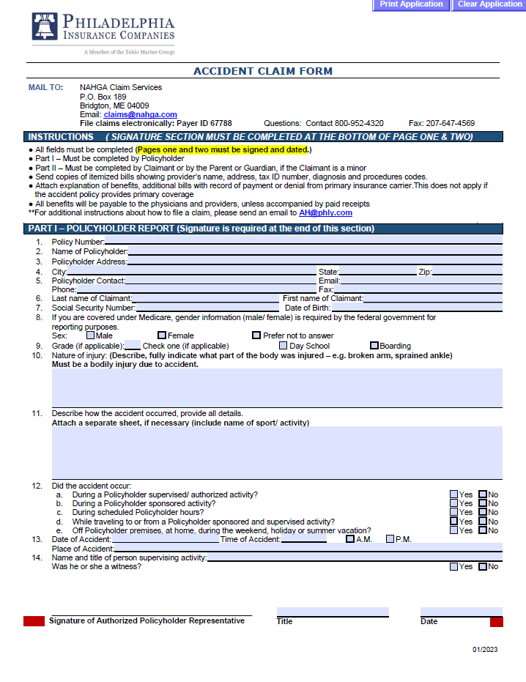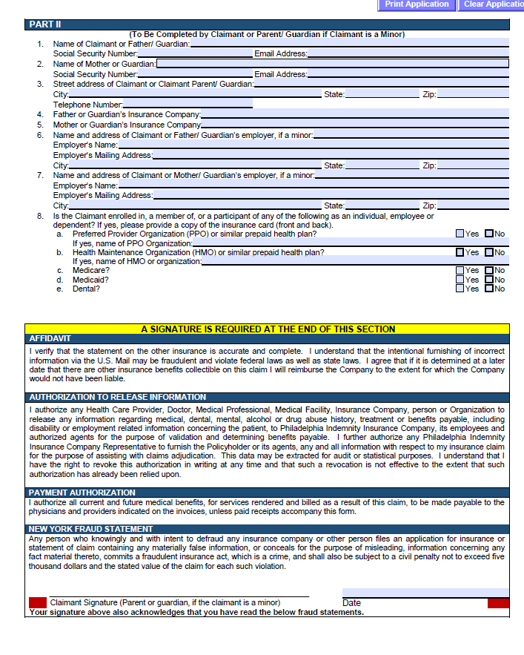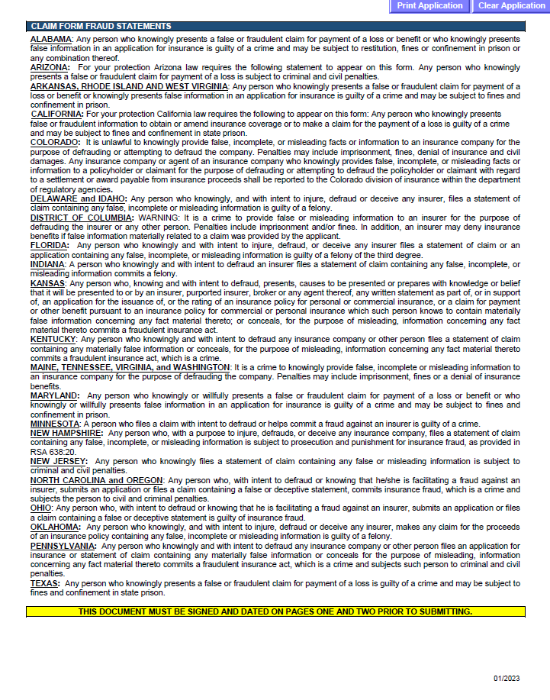

Harassment Complaint Form
Name of the Complainant:
Volunteer Site:
Phone Number:
E-mail:
Today’s Date:
Name of the Accused:
Volunteer site:
Relationship of the Accused to the Complainant (volunteer supervisor, store manager, etc. ):
Phone Number:
E-mail:
Date and Time of Incident: (If more than one event, please report each event on a separate form.)
Where did the specific event occur? Please explain the events that occurred. How did you react to the situation? Did you take any action to stop perceived inappropriate behavior?
Describe the harm you have suffered because of the event. Were there any witnesses to this specific event? (If yes, please provide their names.)
Is there any physical evidence that supports your complaint? If so, please describe or attach copy of evidence.
What is your desired outcome of the investigation?
The information provided in this complaint is true and correct to the best of my knowledge. I am willing to cooperate fully in the investigation of my complaint and provide whatever evidence Habitat for Humanity Washington D.C. & Northern Virginia deems relevant.
Signature of Complainant: Date:
Signature of Person Completing the Form if not the Complainant: Date:
Please return this form to Rachel Jones, the Director of Volunteer & Community Engagement at rachel.jones@habitatdcnova.org

Background and Sex Offender Registry Check Policy
Criminal Background Check Policy

- Purpose

Habitat for Humanity of Washington D.C. & Northern Virginia (Habitat DC-NOVA) values the safety of children, our employees, and volunteers. We want to take prudent measures to protect our human and material resources.

- Policy
Habitat DC-NOVA requires that criminal background checks be conducted for all employees and key volunteers, and in particular, those who may have unsupervised contact with a child, the elderly or persons with disabilities. The cost of all background checks will be borne by Habitat DC-NOVA.
Habitat DC-NOVA reserves the right to recheck criminal backgrounds at any time during the course of service.

Any person who does not consent to a criminal background check will not be permitted to become a key volunteer or employee with Habitat DC-NOVA.
2.1 Disqualification Criteria
A previous conviction may disqualify an applicant from employment or board members and volunteers from service with Habitat DC-NOVA. In determining eligibility, Habitat DC-NOVA, uses a points system (criminal background check evaluation template found in Exhibit D) to rank the level of risk for a particular position or duty before conducting an individualized inquiry to determine if the applicant should be denied. In certain cases, Habitat DC-NOVA may conduct an individualized inquiry without utilizing the point system.
Following this evaluation, Habitat DC-NOVA, in its sole discretion, will make an individualized inquiry to determine if the information on the report is related to the position and consistent with Habitat DC-NOVA’s business necessity and may consider several factors, including, without limitation, the:
- specific duties and responsibilities necessarily related to the employment;
- fitness or ability of the person to perform one or more job duties or responsibilities given the offense;
- time elapsed since the occurrence of the offense;
- age of the applicant when the offense occurred;
- frequency and seriousness of the offense
- information provided by applicant or on his or her behalf that indicates rehabilitation or good conduct since the offense occurred.

2.2 Examples of Disqualification Warranted

If a person withholds information or falsifies information pertaining to previous convictions, the person may be disqualified from further consideration.
Habitat DC-NOVA reserves the right to weigh disqualification criteria on a case-by-case basis and to make selection decisions in its sole discretion. Disqualification may extend to any volunteer position with Habitat DC-NOVA.
- Procedure

Habitat DC-NOVA will comply with the following procedures when conducting criminal background checks:
- refrain from conducting any background check or inquiring about a criminal conviction prior to extending an applicant a conditional offer of employment. Habitat DC-NOVA will make a good faith effort in the case of volunteerism;
- seek prior written approval from the applicant, employee, or volunteer in accordance with applicable laws, and in particular, where third party vendors are retained to conduct criminal background checks;
- review criminal background checks that reveal convictions and determine within a reasonable time whether such convictions disqualify individuals from positions; and/or
- notify the individual under consideration that an offer for any personnel action (employment, transfer, promotion, reclassification, or change in duties) is conditioned on successful completion of the criminal background check, and that falsification of information submitted may be cause for corrective action, up to and including dismissal.
Habitat DC-NOVA will make good faith efforts to comply with the following procedures when conducting criminal background checks:
- Use SterlingVolunteers to run a background check that pulls from Government Watch List, DOJ Sex Offender Registry, and local criminal history
- ensure all recruitment information, applications, announcements, and descriptions state the position, whether paid or unpaid, requires a criminal background check;
- initiate criminal background checks prior to the transfer, promotion, or reassignment of individuals, including reclassification;
  - Denial of Application, Termination or Reassignment
Based on any or all of the criteria outlined in this policy, Habitat DC-NOVA may, in its sole discretion, decide that a volunteer will be dismissed. In the volunteer context, Habitat DC-NOVA may, in its sole discretion, also choose to reassign a former convict to a job involving less exposure to risk. In doing so, Habitat DC-NOVA may, in its sole discretion, consider:
- the type and location of the job – whether it would give the offender access to potential victims;
- the types of co-workers and subordinates in the workplace;
- whether the job would involve travel;
- work hours;
- degree of supervision; and/or
- amount of access to technology, i.e., the Internet.

Applicant ______________________________________

CRIMINAL OFFENSE STATUS EVALUATION FORM FOR EMPLOYEES AND VOLUNTEERS
Risk to Partnership: 15=HIGH 10=MODERATE 5=LOW 0=LITTLE OR NO RISK

- 0 | A. Applicant convicted of a crime? Yes (10 points) No (0 points)
15 10 5 0 | B. Age of applicant at time of commission of the crime:  <16 years old (0 points) 16-17 years old (5 points)  18-20 years old (10 points) 21 years or older (15 points)
15 10 5 0 | C. Time since conviction:  Less than 2 years (15 points) 3-5 years (10 points)  6-10 years (5 points) More than 10 years (0 points)
10 0 | D. Off Probation/Supervision? Yes (0 points) No (10 points)
15 10 5 0 | E. Nature of offense:  Felony (15 points) Gross Misdemeanor (10 points)  Misdemeanor (5 points) Petty misdemeanor (0 points)
- 0 | F. More than one conviction? Yes (10 points) No (0 points)
10 0 | G. Does the nature of the conviction relate to the nature, duties and responsibilities of the position? Yes (10 points) No (0 points)
- -5 | H. Is there evidence of rehabilitation, i.e., Certificate of Rehabilitation or Good Conduct? Yes (-5 points) No (0 points)
Total:______ | (If applicant obtains 30 or more points, the applicant will receive an individualized evaluation to ensure that any denial is sufficiently related to a Habitat for Humanity business necessity.)
Sexual Offender Registration Check Policy
1.0 Purpose
Habitat for Humanity of Washington, D.C. & Northern Virginia (Habitat DC-NOVA) values the safety of children, our employees and volunteers. We want to take prudent measures to protect our human and material resources.
2.0 Policy
Habitat DC-NOVA requires that sex offender registry checks be conducted for all potential employees and key volunteers at the outset of prospective employment or volunteering (subject to any state laws which restrict the timing of when a background check may be conducted) and may run subsequent background checks during the term of employment or continued volunteering where there is an independent, objective basis to do so. The cost of all background checks will be borne by Habitat DC-NOVA.
Habitat DC-NOVA reserves the right to recheck sex offender status at any time during the course of employment and/or service. This policy applies only to sex offender registry checks for current and prospective employees and key volunteers.
Any person who does not consent to a sex offender registry check will not be permitted to become an employee and/or volunteer with Habitat DC-NOVA. Any person on the sex offender registry will not be considered for a volunteer position.
2.1 Disqualification Criteria
A sex offender registry finding may disqualify an applicant from employment or board members and volunteers from service with Habitat DC-NOVA. In determining eligibility, Habitat DC-NOVA, in its sole discretion, will make an individualized inquiry to determine if the information on the report is related to the position and consistent with Habitat DC-NOVA’s business necessity, and may consider several factors, including without limitation, one or more of the following:
- specific duties and responsibilities necessarily related to the employment;
- fitness or ability of the person to perform one or more job duties or responsibilities given the offense;
- time elapsed since the occurrence of the offense;
- age of the applicant when the offense occurred;
- frequency and seriousness of the offense;
- information provided by applicant or on his or her behalf that indicates rehabilitation or good conduct since the offense occurred.

2.2 Examples of Disqualification Warranted
If a person withholds information or falsifies information pertaining to a sex offense, the person may be disqualified from further consideration.
The following list provides some examples in which Habitat DC-NOVA may, within its sole discretion, determine that an individual is ineligible for employment and/or service:
- child molestation conviction of a Faith Community Relations Manager applicant;
- statutory rape conviction of a Volunteer Coordinator applicant; and/or
- conviction for an offense related to child pornography of a Family Services Coordinator applicant;
This list is not exhaustive and is for illustrative purposes only.
Habitat DC-NOVA reserves the right to weigh disqualification criteria on a case-by-case basis and to make selection decisions in its sole discretion. Disqualification may extend to any and to any employee or volunteer position with Habitat DC-NOVA.
2.3 Employment Offer Contingent on Sex Offender Registry Check
In the employment context, Habitat DC-NOVA may extend an offer of employment to an applicant that is contingent on the completion of the sex offender registry check. However, the applicant may not start work before the sex offender registry check has been completed and the final employment and/or service eligibility decision has been made by Habitat DC-NOVA personnel and/or Board of Directors.
3.0 Procedure
Habitat DC-NOVA will comply with the following procedures when conducting sex offender checks for employees, and Habitat DC-NOVA will make a good faith effort as it pertains to volunteers:
- in the employment and volunteerism context, refrain from conducting any background check or inquiring about a sex offender conviction prior to extending an applicant a conditional offer of employment or volunteerism;
- utilize the National Sex Offender Public Website (http://www.nsopw.gov) as a resource and check all states in which the person has resided for the last ten (10) years (or the length of time permitted under state law);
- ensure all recruitment information, applications, announcements, and descriptions state the position requires a sex offender registry check;
- seek prior written approval (even though federal law only requires approval when using a third party consumer reporting agency);
- initiate sex offender registry checks prior to the hire, transfer, promotion, or reassignment of individuals, including reclassification;
- notify the individual under consideration that an offer for any personnel action (employment, transfer, promotion, reclassification, or change in duties) is conditioned on successful completion of the sex offender registry check, and that falsification of information submitted may be cause for corrective action, up to and including termination; and/or
- review sex offender registry checks that reveal convictions and determine within a reasonable time whether such convictions disqualify individuals from positions.
3.1 Denial of Application, Termination or Reassignment
Based on any or all of the criteria outlined in this policy, Habitat DC-NOVA may, in its sole discretion, decide that an employee will be terminated, a volunteer will be dismissed or an applicant will not be hired. In the employment or volunteer context, Habitat DC-NOVA may, in its sole discretion, also choose to reassign a former sex offender to a job involving less exposure to risk. In doing so, Habitat DC-NOVA may, in its sole discretion, consider:
- the type and location of the job – whether it would give the offender access to potential victims;
- the types of co-workers and subordinates in the workplace;
- whether the job would involve travel;
- work hours;
- degree of supervision; and/or
- Amount of access to technology, i.e., the internet

Applicant ______________________________________

SEXUAL OFFENDER STATUS EVALUATION FOR EMPLOYEES
Risk to Partnership: 15=HIGH 10=MODERATE 5=LOW 0=LITTLE OR NO RISK

10 0 | A. Applicant or family member registered on the sex offender registry? Yes  (10 points) No (0 points)
15 0 | B. Life Registration? Yes (15 points) No (0 points)
15 10 5 0 | C. Time since registered: Less than 2 years (15 points) 3-5 years (10 points)  6-10 years (5 points) More than 10 years (0 points)
10 0 | D. Off Probation/Supervision? Yes (0 points) No (10 points)
10 0 | E. History of repeat offenses? Yes (10 points) No (0 points)
10 0 | F. Restrictions on where offender can live? Yes (10 points) No (0 points)
15 0 | G. Nature of offense: Offense with a child? Yes (15 points) No (0 points)
________ | H. Nature of offense: Assault with minor (any degree) (15 points)
 | First degree Assault (15 points)
 | Second, Third, Fourth Degree Assault (10 Points)
 | Sexual Misconduct w/minor (10 points)
 | Sexual Misconduct (5 points)
Misconduct with minor—proximate age (0 points)
Designated as sexual predator (15 points)
Total: ______ | (If applicant obtains 30 or more points, the applicant will receive an individualized evaluation to ensure that any denial is sufficiently related to a Habitat DC-NOVA business necessity.)

Confidentiality Agreement
Habitat for Humanity of Washington, D.C. & Northern Virginia (Habitat DC-NOVA) respects and values the privacy of our homeowners, donors, volunteers and staff as a basic tenet of our organization. As a volunteer or an employee of Habitat DC-NOVA, you may be exposed to information which is confidential and/or privileged in nature. It is the policy of Habitat DC-NOVA that such information must be kept confidential both during and after your service as a volunteer or employee.

We ask that all volunteers and employees ensure that:

- Personal and financial information of homeowners, donors, volunteers and employees is kept confidential and should not be disclosed or discussed outside the duties of volunteer or employee position.
- Any confidential information belonging to, or obtained through their affiliation with Habitat DC-NOVA will be not disclosed to any person, including relatives, friends, and business and professional associates, unless authorized by Executive Director.
- Any information including files, data, documents (both electronic or hard copy), notes, electronic messages (received or transmitted) containing information of homeowner, volunteers or staff is confidential and the sole property of Habitat DC-NOVA.
- At the time of separation from employment or expiration of volunteer position, staff and volunteers are expected to return materials containing privileged or confidential information.
- If a volunteer or staff member believes there has been any violation, unintentional or otherwise, of this policy has occurred, they will notify their supervisor and/or the Executive Director immediately.

Unauthorized disclosure of confidential or privileged information is a serious violation of this policy and will subject the person(s) who made the unauthorized disclosure to appropriate discipline, including removal/dismissal and/or prosecution according to Habitat DC-NOVA policy and any applicable laws.

My signature below acknowledges that I have read, understand, and will comply with the Confidentiality Agreement as outlined in this document:

Printed Name: _______________________________________________________

Signature: ___________________________________________ Date: _ _ /_ _ /___

Supervisor Signature:__________________________________________________
Volunteer Dismissal Form
A volunteer may be asked to leave the service of Habitat DC-NOVA for any reason at any time. Possible grounds for dismissal may include, but are not limited to: gross misconduct or insubordination; theft of property or misuse of ReStore or construction merchandise and equipment; abuse or mistreatment of customers, staff, or other volunteers; failure to abide by agency policies and procedures; inability to arrive on time or not cancelling chosen volunteer shifts; and failure to satisfactorily perform assigned duties.
Name of Volunteer:
Name of Supervisor:
Date of 1st Conversation:
1st Conversation Notes:
- What is the volunteer issue?

- What was said in the conversation to resolve the issue and how did the volunteer respond?
Date of 2nd Conversation:
2nd Conversation Notes:
- What is the volunteer issue?

- What was said in the conversation to resolve the issue and how did the volunteer respond?
Date of dismissal:
What are the reasons for dismissal?
Explain why this conflict resulted in dismissal.
_____________________________________________________
Supervisor Signature
_____________________________________________________
Date
Please return this form to the Director of Volunteer & Community Engagement.

Key volunteer” refers to: (1) any volunteer, who, through Habitat programming, oversees other volunteers or connects directly with customers or homeowners and/or (2) anyone who reaches 100 hours of service. ;
Key volunteer” refers to: (1) any volunteer, who, through Habitat programming, (1) a oversees other volunteers or connects directly with customers or homeowners and/or (2) anyone who reaches 100 hours of service. ;

